**Chapter 7 Monitoring and control systems**

Light sensor:burglar alarm

barcode scanner

Temperature sensor:air conditional

fridge

oven

Motion sensor:phone(accelerometer)

smart wear/watch

Magnetic field sensor:phone(compass app)

Gas sensor:gas water heater

formaldehyde detector

Pressure sensor:weight scale/weighting-mechine

Moisture and humidity sensor:automated farming

air purifier

better air conditional

pH sensor:automated water pollution detection system

Monitoring system and control system:

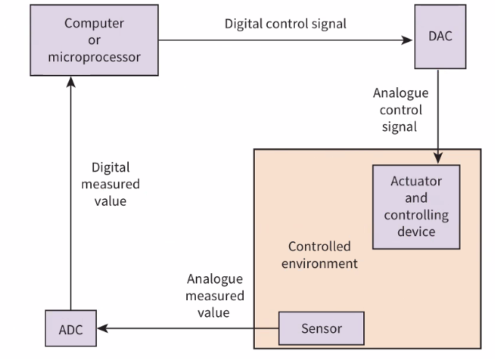

sensor feedbacks continuely/repidly

SYSTEM Q(EXPLAINATION). ANSWERING MODEL

* When the [ ] sensor detects { A }
* A message is sent to the microprocessor which
* sends a signal to an actuator to active device to DO{B}
* A [ ] sensor continuously records the {DETAIL}
* and sends the readings to the microprocessor
* The microprocessor compares the readings with a pre-set value
* When[ {A} is be achieved/{DETAIL} IS TURE ]
* the microprocessor sends a signal to the actuator to STOP device to DO{B}